PART I: Request GCP Free Credit Coupon and Redeem It (20 Points)
TO-DO
• Access the link provided in the instructor’s announcement email to request a free credit coupon.
• Redeem the free credit coupon following the instructions in GCP’s email.
• Capture the screenshot that shows “Billing Account for Education.”
SUBMISSION REQUIREMENT PART I
Answer:
The below screenshot shows the free credits are successfully redeemed.
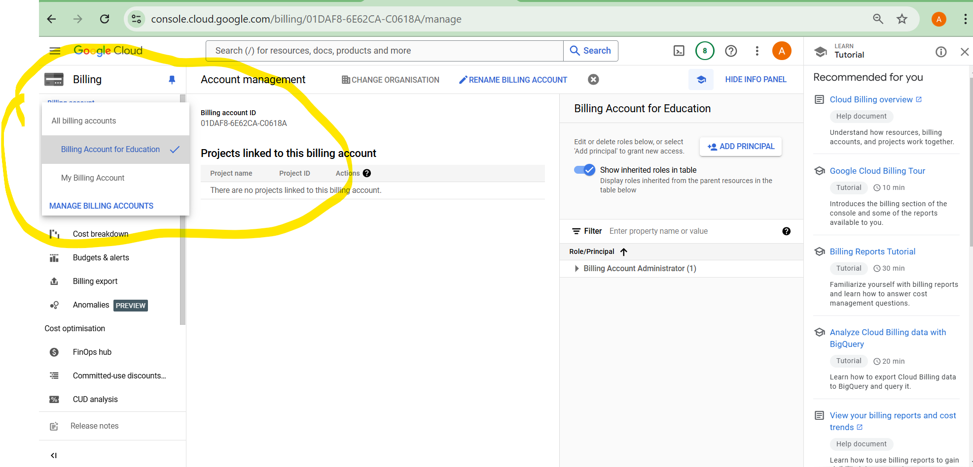

PART II: Build, Train, and Test an LSTM with Time Series Data (50 Points)
SUBMISSION REQUIREMENT #1
--) Submit a Jupyter Notebook document (in its native format, not PDF) that shows coding all the steps and the results of each step while redoing the project.
Answer: The Jupyter notebook will be submitted as part of this assignment.
Jupyter notebook: ADTA_5560_Assignment_4_Part_II_LSTM.ipynb

PART II: Write the Project Report (30 Points)
--) Write a report on the results of the project.
SUBMISSION REQUIREMENT #2:
--) Submit the report in an MS Word document.
Answer:
Report: Build, Train, and Test an LSTM with Time Series Data
Objective: To build, train and test an LSTM with Time Series Data (stock price) of Tesla. We will also evaluate the model for the forecasting the stock price using the historical data.
Data Set: The dataset used in this assignment is the Stock prices of Tesla from the year 2022 to 2024.
Target Variable: The target variable for training, testing and evaluating is “Close” (Closing price of Tesla).
The below steps were performed as part of this assignment.
- Importing libraries:
  - The required libraries were imported to successfully build the RNN
    - timeseries RNN and LTSM neural network
    - basic libraries
    - keras: TimeseriesGenerator
    - keras: MinMax scalar
- Loading Dataset and EDA:
  - Loaded the dataset using pandas “read.csv()” method.
  - Performed a brief exploratory data analysis to have a snapshot of the data.
  - Created a dataset only with the target field “Close” (Closing price for Tesla Stocks).
  - Length of the input time series is set to 60. This means 60 datapoints from the dataset will be used to predict/forecast the next one value.
- Split Train and Test Data:
  - The data is split into training and testing with test data set having 10% of the data.
- Normalize the data:
  - We have used MinMaxScalar.
  - We are scaling only the training data. We are not scaling the testing data
  - Then we transform both training data and testing data.
- Generate Time Series batches for training:
  - We have used the Time Series Generator for creating the time series batches for modelling.
- Building the LSTM Model:
  - The model has three LSTM layers with 50 units/LSTM cells each and activation function as “relu”.
  - The model has two Dropout layers and one Fully Connected layer.
- Compile the Model:
  - We compile the model using model.compile().
- Fit the model:
  - We fit the model using timeseries generator and 100 epoches.
- Visualize the model’s performance after training
  - We plot the loss function to understand the model performance.
  - The below plot shows the loss function.
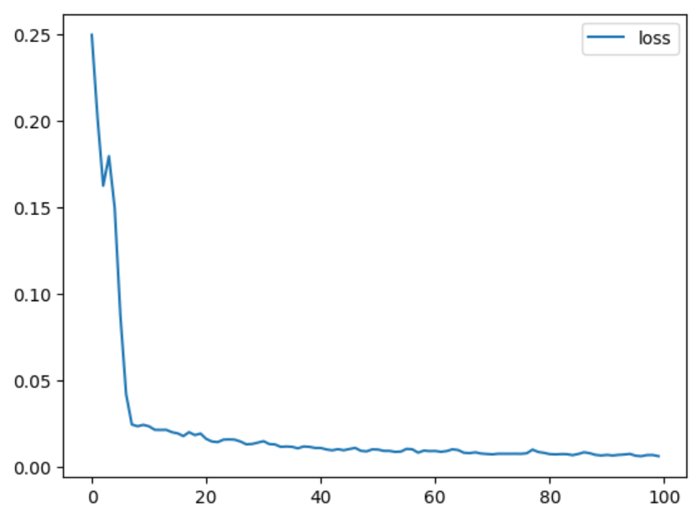
- Prediction For Testing:
  - Create time series generator for testing.
  - Predict the future data points.
- Visualize the prediction.
  - The below plot shows the actual and the prediction.
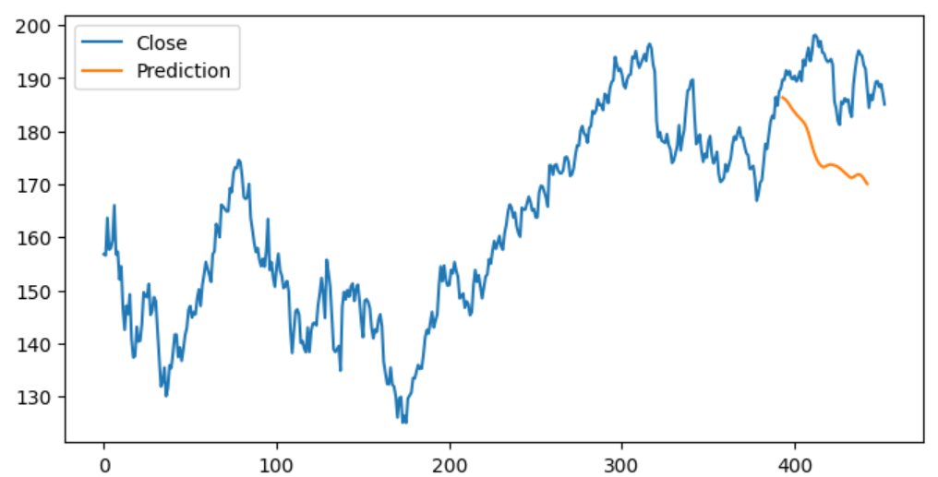
- Forecasting with LSTM
  - Preprocess full input dataset
  - Create a time series generator for forecasting
  - Fit LSTM model for forecasting
  - Forecast using the LSTM neural network
- Revert the scaled values back to real values
  - Use inverse transform to revert the scaled values to real values.
- Create a new timestamp index with forecast
  - This index is passed to the forecast dataframe
- Plot the actual and forecasted values
  - The below plot shows the actual close values
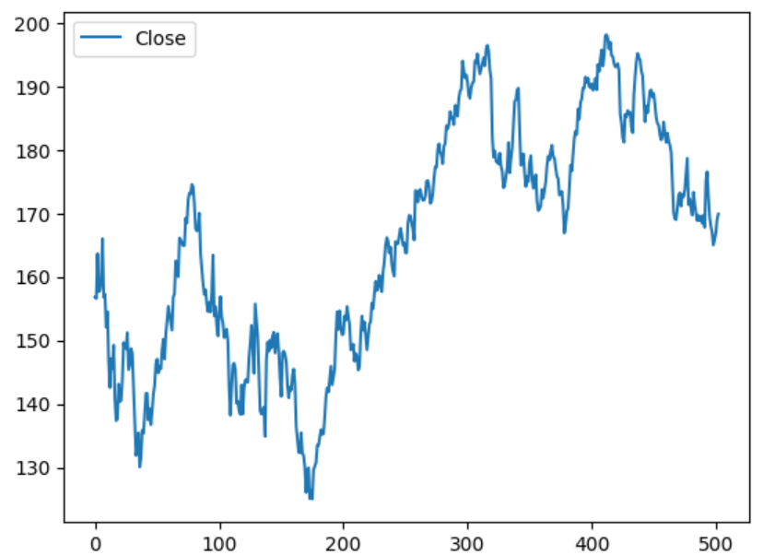
  - The below plot shows the forecasted close values
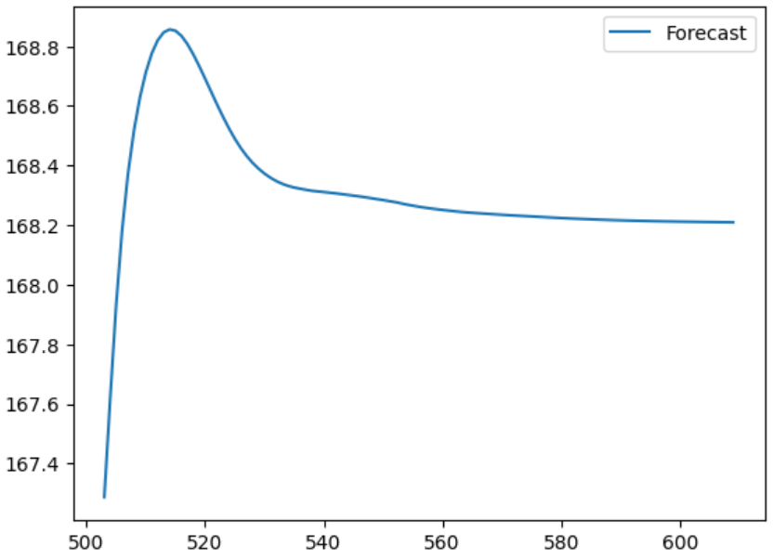
- Join the two plots to get the actual and forecasted close values.
  - The below plot shows the actual and forecasted close values.
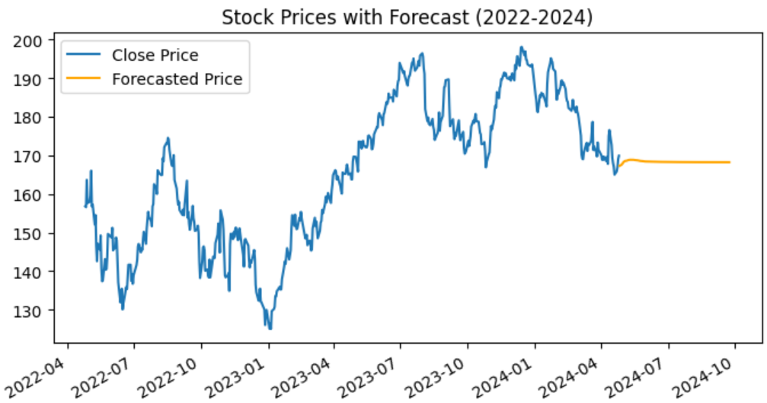
Conclusion: In this assignment we successfully loaded the TESLA stock price dataset, split the generated dataset into training and testing dataset. We also normalized the data, built the model with three LSTMs, two dropout layers and one fully connected layer, trained the model, visualized the model’s performance and forecasted the close values. We also plotted the predicted and original close values.
Note:
- The jupyter notebook is having this code is uploaded as part of this assignment.
- The below code is deprecated. I have used an alternate code.
- Given Code: #model.fit_generator(train_tsGenerator60, epochs=100)
- Alternate code: model.fit(train_tsGenerator60, epochs=100)

